
Student Name:____________________________

Eastern Goldfields College

Applications – Unit 2 - 2017

Investigation 4 (U2 I2) – Piecewise and Step Functions
Working Time: 50 mins | Calculator, No notes Total Marks: 45

Task weighting: 5% (U2 10%) VALIDATION

Question 1 (5 marks)
Ida parks her car at 8.00 am at the university where parking costs $1.50 per hour. She leaves there at 10 am and arrives at the airport at 10:45 am where she parks the car for an hour at $4 per hour. She then drives to the city, arriving at 12.15 pm and parks on the Esplanade at a cost of $4.50 per hour for 2 hours. She then leaves the city and drives home, arriving there at 3.00 pm.

Use the axes below to graph the amount Ida pays for parking from 8.00 am to 3.00 pm.
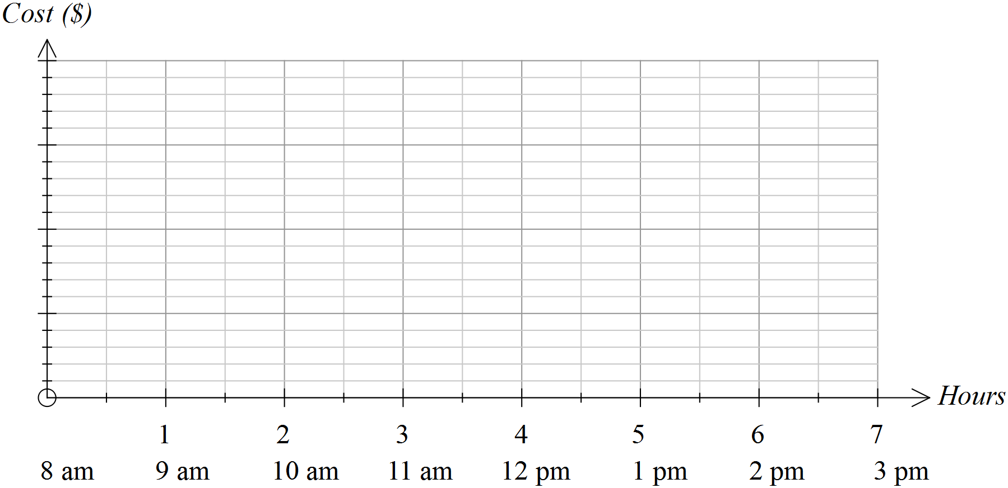

Question 2 (5 marks)
The cost of parking at the airport for up to 5 hours is summarised in the table. Show these costs on the axes provided.

First 15 mins | Over 15 mins  Up to 30 mins | Over 30 mins  Up to 1 hour | Over 1 hour  Up to 2 hours | After 2 hours it is an extra $2 per hour or part thereof
Free | $5 | $8 | $12 | After 2 hours it is an extra $2 per hour or part thereof
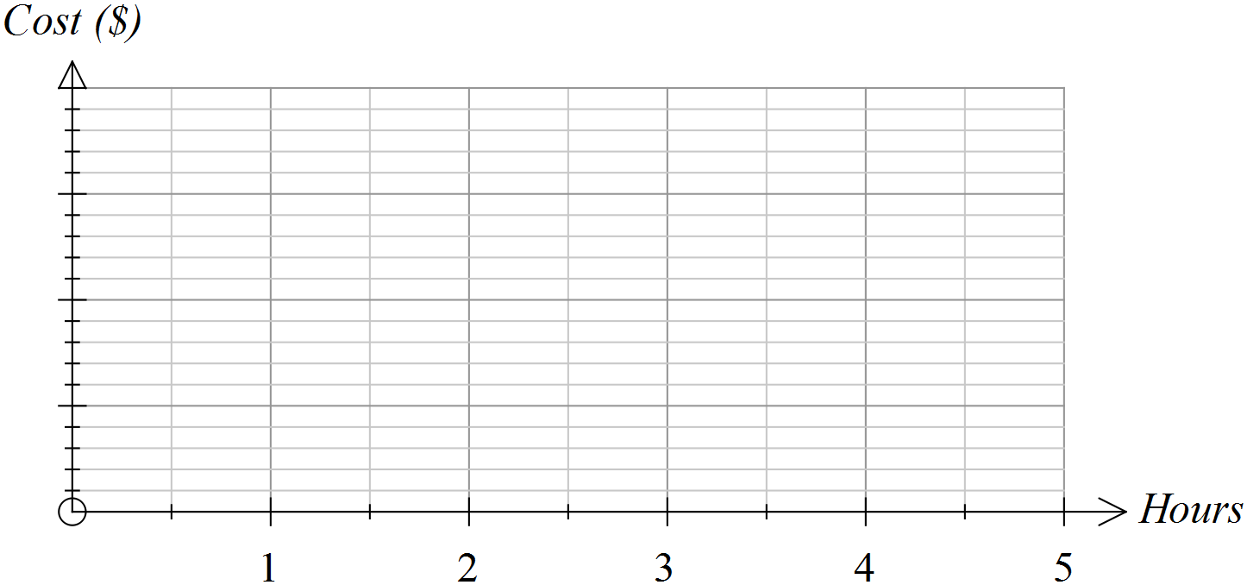

Question 3 (10 marks: 1, 1, 1, 2, 2, 3)
The costs of sending parcels of varying weights by post are represented in the graph below.
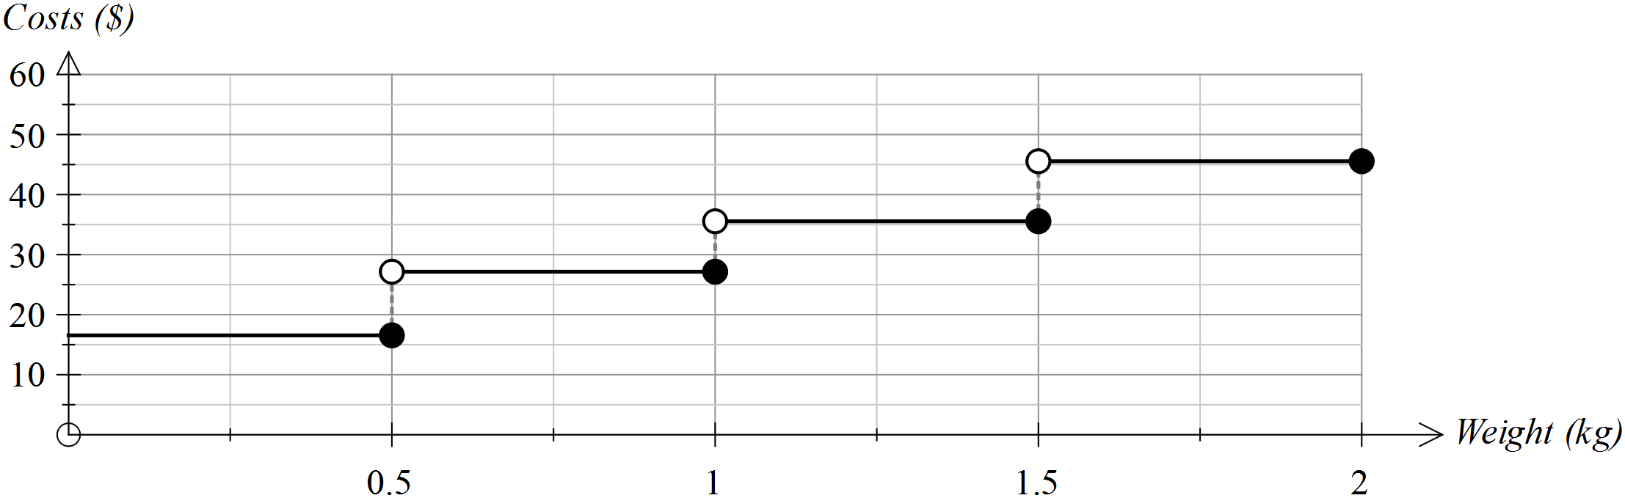

Use the graph to answer the following questions.
(a) What is the approximate cost of sending a parcel weighing 500 g?
(b) What is the approximate cost of sending a parcel weighing 120 g?

(c) If you had $40 to spend on the postage of one parcel, what is the
maximum weight that the parcel could be?
(d) If you were told that your parcel would probably cost less than $30,
what might its weight be?

(e) A decision was made to lower the costs by $10 in each weight range. Draw the graph showing these lowered costs on the graph drawn ABOVE.
(f) A decision was made to lower the costs by 50% in each weight range. Draw the graph showing these lowered costs on the graph drawn BELOW.

Question 4 (9 marks: 1, 1, 2, 1, 2, 2)
Tom and Mary were driving in a car rally last week. The time taken to return to their starting point is shown in the graph below.
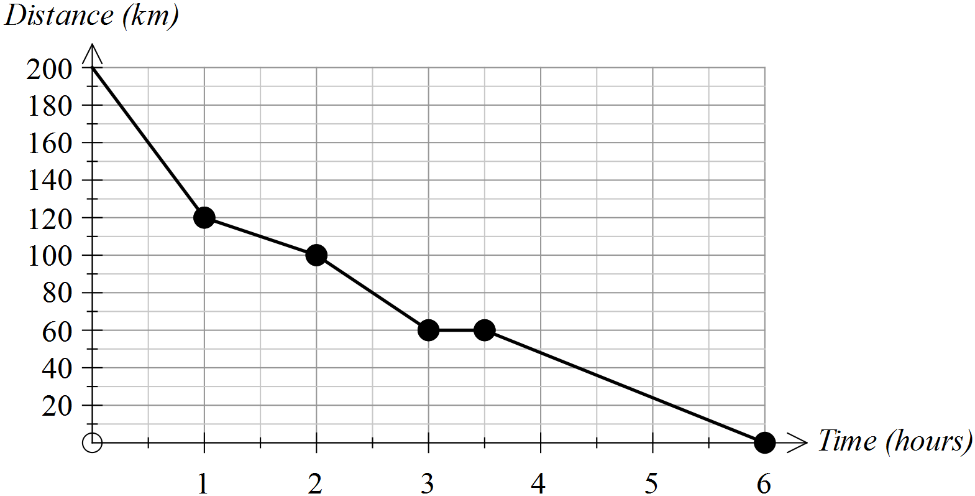

(a) How far was the return journey? _______________

(b) How long did the return journey take? _______________
(c) During which hour did Tom and Mary average the highest speed? How did you determine this answer from
the graph?

(d) For how long did Tom and Mary stop? _______________
(e) At what average speed were Tom and Mary travelling during the last hour of their journey? Show how you determined your answer.

(f) Tom and Mary started their return journey at 6.00 am.
(i) How far had they travelled by 8.30 am? _______________

(ii) Add a segment to this graph to indicate that Tom and Mary could have travelled at a constant speed between 9.00 am and 11.00 am.

Question 5 (16 marks: 3, 8, 2, 3)
The cost of travelling on a city train varies according to the number of zones travelled. The table provided shows the:
- stations numbered 1 to 9
- distance to each station from the city
- cost of travelling to that station from the city
- time taken to reach each station from the city.

Station | Distance from city (km) | Cost  from the city | Time taken from city (mins) | Time taken since last station (mins) | Distance since last station (km) | Cost since the last station
1 | 7.3 | $2.90 | 6 | 6 | 7.3
2 | 11.7 | $4.40 | 9 | 3 | 4.4
3 | 13.8 | $4.40 | 11 |  | 2.1
4 | 20.5 | $5.30 | 16 |  | 6.7
5 | 32.9 | $6.30 | 23 |  | 12.4
6 | 37.39 | $6.30 | 29 |  | 4.49
7 | 43.2 | $7.80 | 33 |  | 5.81
8 | 47.6 | $7.80 | 36 |  | 4.4
9 | 70.19 | $10.30 | 48 |  | 22.59 | $2.50

(a) Complete the table above.
(b) The graph below shows the cost of travel according to the distance travelled.
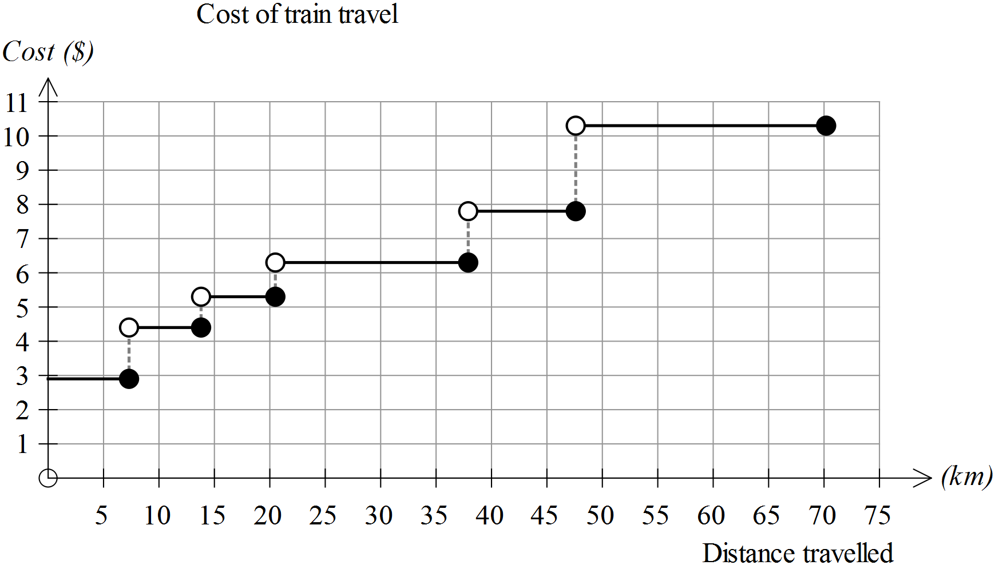

(i) How many different prices are used for this schedule of costs? _______________

(ii) At which distance from the city does the sharpest rise in costs occur? _______________

(iii) What would you need to do to this graph to show an increase of $1 on all the fares given in the table?

(iv) For people who receive a 15% discount on their fares, how would their graph of costs be different to the one above?

(v) It was suggested that, rather than increase the fares the same fares would apply, but the stations would be moved so that they were closer to the city. How would the new graph of costs differ from the one given?

(c) If you plotted time on the horizontal axis and distance travelled on the vertical axis, would you create a step graph or a piece-wise linear graph? Justify your conclusion.

(d) Is the following statement True or False? Justify your conclusion.
The further you travel from the city, the less it costs per kilometre.

End of questions

